LOAN APPROVAL DASHBOARD

Project Documentation

1. Abstract
The AI Loan Approval Dashboard is a web-based application developed using HTML, CSS, JavaScript, and Chart.js to simulate an intelligent loan eligibility prediction system. The system analyzes several user inputs such as income, credit score, loan amount, loan purpose, employment status, marital status, and education status. Based on these parameters, the system calculates a probability score that determines whether a loan should be approved or declined.
The main goal of this project is to demonstrate how a simple artificial intelligence-based scoring model can assist financial institutions in making faster and more consistent loan decisions. The dashboard also provides visual representation of the decision using graphical charts, making it easier for users to understand the approval probability.
The system improves decision transparency by showing approval and decline probabilities through bar charts and also maintains a small history counter showing the number of approvals and declines. This project demonstrates how AI-inspired decision models can be implemented in web applications to support financial decision making.

2. Introduction
Loan approval is an important process in the banking and financial sector. Traditionally, loan approval decisions are taken by bank officials after analyzing the applicant’s financial information, employment status, credit score, and other related factors. This manual process can be time-consuming and may sometimes lead to inconsistent decisions.
With the growth of Artificial Intelligence and Machine Learning, automated loan decision systems are becoming increasingly popular. These systems evaluate applicants based on predefined rules or trained models and generate quick results.
The AI Loan Approval Dashboard is designed as a simplified model of such systems. It allows users to input personal and financial details and automatically predicts loan eligibility using a scoring algorithm.
The dashboard interface is designed with a modern UI and glass-style design, along with a financial themed background. The system also uses Chart.js to display prediction results visually. This project demonstrates the concept of AI-driven decision support systems in a simple and understandable way.

3. Objectives
The main objectives of the AI Loan Approval Dashboard are:
- To design a web-based system that predicts loan eligibility.
- To simulate an AI-based loan approval process using JavaScript.
- To allow users to input financial and personal information for evaluation.
- To calculate loan approval probability using a scoring algorithm.
- To visualize prediction results using graphical charts.
- To maintain approval and decline statistics.
- To create a simple and user-friendly interface for loan evaluation.
- To demonstrate how AI concepts can be applied in financial applications.

4. Existing System
In the traditional loan approval system, loan applications are reviewed manually by bank officials. The applicant submits documents such as income statements, credit history, employment verification, and identification details.
The bank officer evaluates these documents and decides whether the loan should be approved or rejected.
However, the existing system has several limitations:
• The process is time-consuming.
• Decisions depend heavily on human judgment.
• There is a possibility of bias or inconsistency.
• Large volumes of applications increase workload.
• Manual verification may lead to delays.
Due to these limitations, many financial institutions are shifting towards automated decision systems powered by AI and machine learning technologies.

5. Proposed System
The proposed system is an AI Loan Approval Dashboard that automatically evaluates loan eligibility using a scoring algorithm. The system collects various parameters from the user and calculates a probability score for loan approval.
The proposed system includes:
• A web-based application interface
• Automatic loan approval prediction
• Graphical representation of results
• Approval and decline tracking system
The system calculates a score based on factors like income, credit score, loan amount, employment status, marital status, education, and loan purpose. Based on the calculated probability, the system displays either APPROVED or DECLINED.
The proposed system provides faster evaluation and improves transparency through visual results.

6. System Design
The system design includes the User Interface Design, Data Input System, Processing Algorithm, and Result Visualization Module.

Input Module
The system collects the following inputs from the user:
• Income
• Credit Score
• Loan Amount
• Loan Purpose
• Employment Status
• Marital Status
• Education Status

Processing Module
The system processes the inputs using a scoring formula that calculates loan approval probability.

Output Module
The result is displayed in two ways:
• Text result (Approved or Declined)
• Graphical chart showing probability percentages.

Interface Design
The interface is divided into two sections:
Left Panel:
- User input form
- Buttons
- Approval history
Right Panel:
- Prediction result
- Chart visualization

7. Methodology and Algorithm

Methodology
The project uses a rule-based scoring model to simulate an AI prediction system. Each input parameter contributes to the final score with different weights.
The system follows these steps:
- Collect user inputs.
- Validate numeric values.
- Calculate weighted score.
- Convert score into probability.
- Display decision result.
- Visualize probability using a chart.

Algorithm
Step 1: Start
Step 2: Read input values (income, credit score, loan amount, etc.)
Step 3: Validate inputs
Step 4: Initialize score = 0
Step 5: Add weighted contributions
score += income / 100000
score += credit / 850
score -= loan / 100000
score += purpose
score += job * 0.4
score += married * 0.2
score += edu * 0.3
Step 6: Calculate probability
probability = score / 3
Step 7: Limit probability between 0 and 1
Step 8: Convert to percentage
Step 9: If probability > 50 → Approved
Step 10: Else → Declined
Step 11: Display result and chart
Step 12: Stop

8. Implementation
<!DOCTYPE html>
<html>

<head>

<title>AI Loan Approval Dashboard</title>

<script src="https://cdn.jsdelivr.net/npm/chart.js"></script>

<style>

body{
margin:0;
font-family:Arial;

/* HD COINS + MONEY NOTES BACKGROUND */

background:url("https://images.unsplash.com/photo-1580519542036-c47de6196ba5?auto=format&fit=crop&w=1920&q=100");

background-size:cover;
background-position:center;

height:100vh;
display:flex;
justify-content:center;
align-items:center;
}

/* GLASS PANEL */

.container{

background:rgba(0,0,0,0.6);

backdrop-filter:blur(6px);

padding:40px;

border-radius:15px;

width:900px;

display:flex;

color:white;

box-shadow:0 0 25px black;

}

/* LEFT PANEL */

.left{

width:40%;
padding-right:25px;

}

/* RIGHT PANEL */

.right{

width:60%;
text-align:center;

}

h1{

color:#FFD700;
margin-bottom:20px;

}

label{

font-weight:bold;

}

input, select{

width:100%;
padding:10px;
margin:8px 0 15px 0;
border:none;
border-radius:5px;

}

/* BUTTONS */

button{

width:100%;
padding:12px;
font-size:16px;
border:none;
border-radius:5px;
cursor:pointer;

}

.check{

background:#FFD700;
margin-top:10px;

}

.reset{

background:#777;
color:white;
margin-top:10px;

}

/* RESULT */

.result{

font-size:45px;
margin-top:20px;
font-weight:bold;

}

.history{

margin-top:20px;
font-size:18px;

}

</style>

</head>

<body>

<div class="container">

<div class="left">

<h1>Loan Application</h1>

<label>Income ($)</label>
<input id="income">

<label>Credit Score</label>
<input id="credit">

<label>Loan Amount</label>
<input id="loan">

<label>Loan Purpose</label>
<select id="purpose">
<option value="0.4">Home Loan</option>
<option value="0.35">Car Loan</option>
<option value="0.3">Education</option>
<option value="0.25">Business</option>
<option value="0.2">Personal</option>
</select>

<label>Employed (1/0)</label>
<input id="job">

<label>Married (1/0)</label>
<input id="married">

<label>Educated (1/0)</label>
<input id="edu">

<button class="check" onclick="predict()">CHECK ELIGIBILITY</button>

<button class="reset" onclick="resetApp()">RESET</button>

<div class="history">

Approved: <span id="yes">0</span> |
Declined: <span id="no">0</span>

</div>

</div>

<div class="right">

<h2>Prediction Result</h2>

<div class="result" id="result">

Awaiting Data

</div>

<canvas id="chart" width="350" height="220"></canvas>

</div>

</div>

<script>

let approveCount=0
let declineCount=0
let chart

function predict(){

let income=parseFloat(document.getElementById("income").value)
let credit=parseFloat(document.getElementById("credit").value)
let loan=parseFloat(document.getElementById("loan").value)
let purpose=parseFloat(document.getElementById("purpose").value)
let job=parseFloat(document.getElementById("job").value)
let married=parseFloat(document.getElementById("married").value)
let edu=parseFloat(document.getElementById("edu").value)

if(isNaN(income)||isNaN(credit)||isNaN(loan)){
alert("Enter valid numbers")
return
}

let score=0

score+=income/100000
score+=credit/850
score-=loan/100000
score+=purpose // Loan purpose influence
score+=job*0.4
score+=married*0.2
score+=edu*0.3

let prob=Math.min(Math.max(score/3,0),1)

let approve=Math.round(prob*100)
let decline=100-approve

if(approve>50){

document.getElementById("result").innerHTML="APPROVED ✅"

approveCount++
document.getElementById("yes").innerText=approveCount

}else{

document.getElementById("result").innerHTML="DECLINED ❌"

declineCount++
document.getElementById("no").innerText=declineCount

}

drawChart(approve,decline)

}

function drawChart(approve,decline){

if(chart){
chart.destroy()
}

let ctx=document.getElementById("chart").getContext("2d")

chart=new Chart(ctx,{

type:'bar',

data:{
labels:['Declined','Approved'],
datasets:[{
label:'Prediction Probability %',
data:[decline,approve],
backgroundColor:['#ff7f7f','#90ee90']
}]
},

options:{
plugins:{
legend:{labels:{color:'white'}}
},
scales:{
x:{ticks:{color:'white'}},
y:{
beginAtZero:true,
max:100,
ticks:{color:'white'}
}
}
}

})

}

function resetApp(){

document.querySelectorAll("input").forEach(i=>i.value="")
document.getElementById("purpose").selectedIndex=0

document.getElementById("result").innerHTML="Awaiting Data"

approveCount=0
declineCount=0

document.getElementById("yes").innerText=0
document.getElementById("no").innerText=0

if(chart){
chart.destroy()
}

}

</script>

</body>
</html>

9. Output

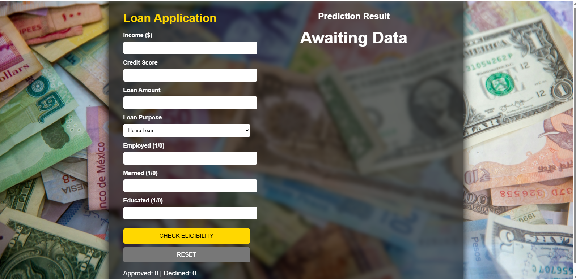10. Result Analysis
The AI Loan Approval Dashboard successfully demonstrates how financial parameters can be used to predict loan eligibility. The system calculates probabilities using weighted scoring and provides immediate feedback to users.
The graphical representation improves user understanding of the prediction results. The approval and decline counters also help analyze the number of accepted and rejected applications.
Although the system uses a simplified algorithm instead of a real machine learning model, it effectively illustrates how automated loan evaluation systems work.

11. Conclusion
The AI Loan Approval Dashboard is a simple yet effective demonstration of an automated loan decision system. It shows how artificial intelligence concepts can be integrated into web applications for financial analysis.
The system allows users to enter their financial information and receive instant loan eligibility results. The use of charts and visual elements makes the system interactive and easy to understand.
This project can be further enhanced by integrating real machine learning models, connecting to databases, and adding authentication features. Overall, the project provides a good foundation for understanding AI-based financial decision systems.

12. Feature Flow
User Opens Dashboard
↓
User Enters Financial Details
↓
Clicks Check Eligibility
↓
System Calculates Score
↓
Probability is Generated
↓
Loan Status Displayed
↓
Bar Chart Shows Probability
↓
Approval / Decline Counter Updates

13. References
- Chart.js Official Documentation
https://www.chartjs.org
- JavaScript Documentation
https://developer.mozilla.org
- HTML & CSS Web Design Concepts
https://www.w3schools.com
- Artificial Intelligence in Finance Research Articles
- Loan Approval Prediction Concepts – Machine Learning Applications in Banking

